- Capacitive Soil Moisture Sensor
Introduction
Soil moisture sensor measures soil moisture levels by capacitive sensing rather than resistive sensing like other sensors on the market. It is made of corrosion resistant material which gives it an excellent service life. Insert it in to the soil around your plants and impress your friends with real-time soil moisture data! This module includes an on-board voltage regulator which gives it an operating voltage range of 3.3 ~ 5.5V. It is perfect for low-voltage MCUs, both 3.3V and 5V. For compatibility with a Raspberry Pi it will need an ADC converter. This soil moisture sensor is compatible with our 3-pin "Gravity" interface, which can be directly connected to the Gravity I/O expansion shield.
Specifications
- Supports 3-Pin Sensor interface
- Analog output
- Operating Voltage: 3.3 ~ 5.5 VDC
- Output Voltage: 0 ~ 3.0VDC
- Operating Current: 5mA
- Interface: PH2.0-3P
- Dimensions: 3.86 x 0.905 inches (L x W)
- Weight: 15g
The Hardware Schematic for Capacitive Soil Moisture Sensor
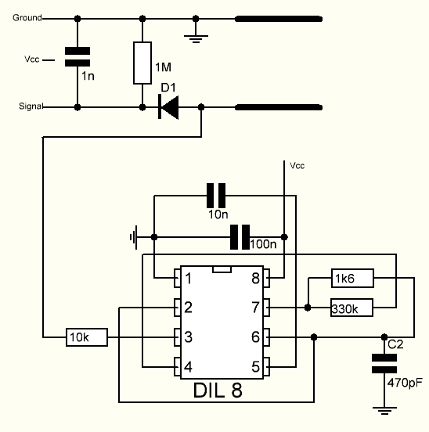
Working Principal
There is a fixed frequency oscillator that is built with a 555 Timer IC. The square wave generated is then fed to the sensor like a capacitor. To a square wave signal that capacitor, however, has a certain reactance, or for argument’s sake a resistance that forms a voltage divider with a pure ohm type resistor (the 10k one on pin 3). The greater is the soil moisture, the higher the capacitance of the sensor. Consequently, there is a smaller reactance to the square wave, thus lowering the voltage on the signal line. The voltage on the Analog signal pin can be measured by an analog pin on the Arduino which represents the humidity in the soil.

How Does a Capacitive Moisture Sensor Work?
Simply stated, a capacitor stores electrical charge.
The electrical component known as a capacitor consist of three pieces. A positive plate, a negative plate and the space in-between the plates, known as the dielectric. The physical form and construction of practical capacitors vary widely and many capacitor types are in common use. Most capacitors contain at least two electrical conductors often in the form of metallic plates or surfaces separated by a dielectric medium.
A capacitive moisture sensor works by measuring the changes in capacitance caused by the changes in the dielectric. It does not measure moisture directly (pure water does not conduct electricity well), instead it measures the ions that are dissolved in the moisture These ions and their concentration can be affected by a number of factors, for example adding fertilizer for instance will decrease the resistance of the soil. Capacitive measuring basically measures the dielectric that is formed by the soil and the water is the most important factor that affects the dielectric.
Capacitive measuring has some advantages, It not only avoids corrosion of the probe but also gives a better reading of the moisture content of the soil as opposed to using a resistive soil moisture sensor. Since the contacts (the plus plate and the minus plate of the capacitor) are not exposed to the soil, there is no corrosion of the sensor itself.
The capacitance of the sensor is measured by means of a 555 based circuit that produces a voltage proportional to the capacitor inserted in the soil. We then measure this voltage by use of an Analog to Digital Converter which produces a number that we can then interpret as soil moisture.

Image of Sensor
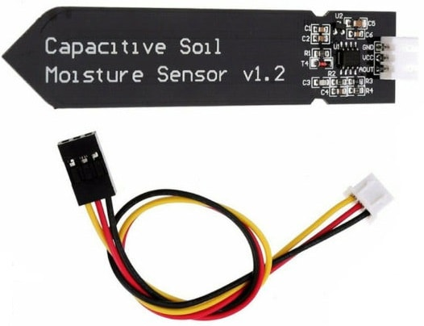

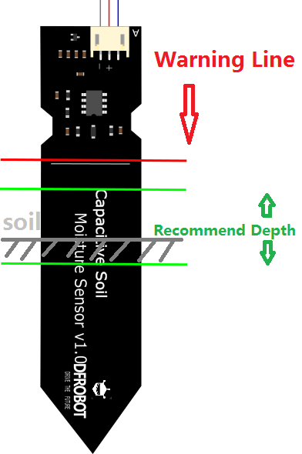

Connection diagram
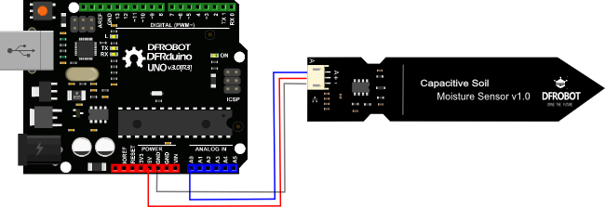

Calibration Code
void setup() {
Serial.begin(9600); // open serial port, set the baud rate as 9600 bps
}
void loop() {
int val;
val = analogRead(0); //connect sensor to Analog 0
Serial.println(val); //print the value to serial port
delay(100);
}
- Open the serial port monitor and set the baud rate to 9600
- Record the sensor value when the probe is exposed to the air as "Value 1". This is the boundary value of dry soil “Humidity: 0%RH”
- Take a cup of water and insert the probe into it no further than the red line in the diagram
- Record the sensor value when the probe is exposed to the water as "Value 2". This is the boundary value of moist soil “Humidity: 100%RH”

Section Settings
The final output value is affected by probe insertion depth and how tight the soil packed around it is. We regard "value_1" as dry soil and "value_2" as soaked soil. This is the sensor detection range. For example: Value_1 = 520; Value_2 = 260. The range will be divided into three sections: dry, wet, water. Their related values are:
- Dry: (520 430]
- Wet: (430 350]
- Water: (350 260]

Test Code
/***************************************************
This example reads Capacitive Soil Moisture Sensor.

Created 2015-10-21
By berinie Chen <bernie.chen@dfrobot.com>

GNU Lesser General Public License.
See <http://www.gnu.org/licenses/> for details.
All above must be included in any redistribution
****************************************************/

/***********Notice and Trouble shooting***************
1.Connection and Diagram can be found here: https://www.dfrobot.com/wiki/index.php?title=Capacitive_Soil_Moisture_Sensor_SKU:SEN0193
2.This code is tested on Arduino Uno.
3.Sensor is connect to Analog 0 port.
****************************************************/

const int AirValue = 520; //you need to replace this value with Value_1
const int WaterValue = 260; //you need to replace this value with Value_2
int intervals = (AirValue - WaterValue)/3;
int soilMoistureValue = 0;
void setup() {
Serial.begin(9600); // open serial port, set the baud rate to 9600 bps
}
void loop() {
soilMoistureValue = analogRead(A0); //put Sensor insert into soil
if(soilMoistureValue > WaterValue && soilMoistureValue < (WaterValue + intervals))
{
Serial.println("Very Wet");
}
else if(soilMoistureValue > (WaterValue + intervals) && soilMoistureValue < (AirValue - intervals))
{
Serial.println("Wet");
}
else if(soilMoistureValue < AirValue && soilMoistureValue > (AirValue - intervals))
{
Serial.println("Dry");
}
delay(100);
}

